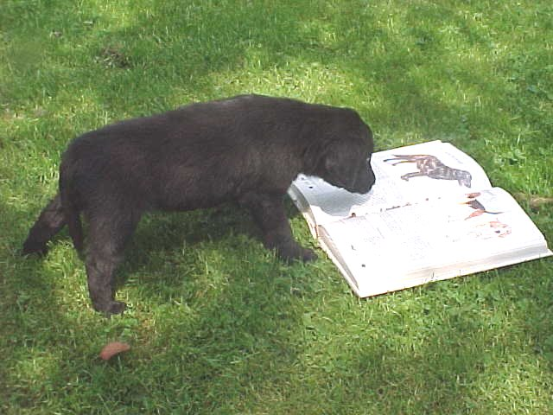

Recommended Reading

How To Raise A Puppy You Can Live With David H. Neil ISBN-13: 9781577790761

The Perfect Puppy Gwen Bailey

The Doglopaedia J.M. Evans & Kay White ISBN 0-9510620-0-X

Flatcoated Retrievers Today Joan Mason ISBN 1=86054-085-6

Flatcoated Retrievers Brenda Phillips ISBN 185279018-0

The Complete Flatcoated Retriever Paddy Petch ISBN 0-85115-463-8

A Review of the Flatcoated Retriever Nancy Laughton ISBN 0-7207 1228 9

The Flatcoated Retriever John Wakefield

The first and last books are good for starters…..

