Northern Lights Flat-Coated Retrievers
FCRMom@comcast.net
Phone: (360-904-7299)
www.nothernlightsfcr.com

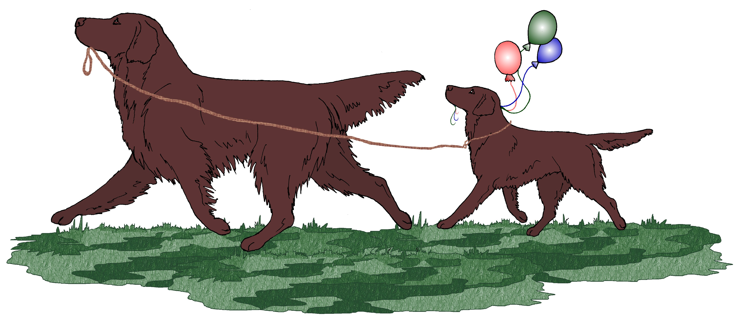

July 30, 2026

Dear Puppy Buyer,

Thank you for inquiring about our upcoming CH Flashback Crazy For Loving You CD CGC “Patsy” x CH Huntlovers Jumping Star Of Bristol “Jake” litter. We will breed Patsy to Jake when she comes in season, probably the beginning of March. Both Patsy and Jake have all appropriate health clearances (eyes, hips, elbows and patellas) and are in sound health and condition. This is a carefully planned breeding and we anticipate producing sound puppies of correct type with performance and field potential, and most importantly the outstanding temperament and personality that make the Flat-Coated Retriever an ideal companion. We place genetics as well as health and longevity at the very top of our priority list when planning a breeding. There will be both black and liver puppies.

Please find enclosed pedigree information and pictures of Patsy and as well as a copy of our contract. You will also find our puppy buyer’s questionnaire. If you would like to be added to our waiting list, please take the time to complete the questionnaire and return it to us at your earliest convenience. If you have any questions or concerns while completing the questionnaire, please feel free to contact us.

The price for these Flashback puppies will be $1,000.00. We anticipate that the breeding will take place between March and May, 2009. When we have confirmed Patsy’s pregnancy we will contact you to find out if you’re still interested in a puppy. When the litter is on the ground, if we think we have a puppy to match your needs and lifestyle we will contact you and a $500 deposit will be due at that time. If we do not have a puppy to meet your needs, we will contact you and let you know that as well. We will be keeping the pups until they are at least 8 weeks old, so the puppies should be ready for their new homes in Summer, 2009. As the puppies develop and mature, should we decide that we don’t have a puppy that is a good match for you, we will return your deposit. Otherwise, the deposit is non-refundable.

We will be keeping pictures of Patsy and her puppies on our website so you can see how they are growing and changing. If you are local, or in the area you are welcome to drop in and visit the puppies.

Here is the link to Patsy’s individual page on the Northern Lights website:
http://www.northernlightsfcr.com/Patsyspage.html
If you’re interested, you can see a pictorial history of Patsy’s entire litter here: http://www.flashbackfcr.com/Introducing%20the%20Flashback%20Litter.htm
Here is the link to Patsy’s individual page on the Flashback website:
http://www.flashbackfcr.com/2008/Patsy%202008.htm
Here is the link to Patsy’s Mom’s individual page on the Flashback website:
http://www.flashbackfcr.com/2008/Snicker%202008.htm

It is extremely important to us to protect and preserve the multi purpose nature of the Flat-Coat. To this end, we expect a lot of our puppy buyers – we ask that you keep in contact with us throughout your dog’s lifetime and that you keep us informed of any health or training problems that you may encounter with your dog. We want you to be educated on the good and the “not-quite-so-good” aspects of Flat-Coats. We would like to be a resource for information and guidance for you, but we also highly encourage you to join the Flat-Coated Retriever Society of America (FCRSA). The FCRSA quarterly newsletter is an invaluable source of information for you.

Again, thank you for your interest in this litter. Please feel free to contact us with any questions that you may have about our dogs, or Flat-Coated Retrievers in general.

Sincerely,

Heather Dawson
Email: FCRMom@comcast.net
Phone: 360-904-7299
Address: 9111 NW Westgate Court
Vancouver, WA 98665
Website: www.northernlightsfcr.com



