SOME HISTORY ON THE DOGS IN PATSY’S PEDIGREE

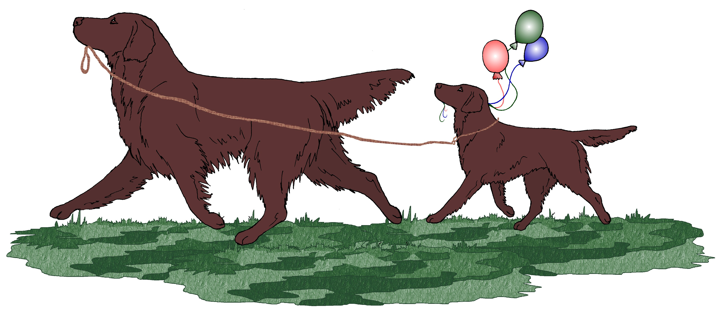

Patsy’s Sire: Casblaidd Don't Pay the Ferryman SDC’A’ SG-WC (“Noof”) This handsome, upstanding UK dog has won well at Championship level and has an outstanding temperament which he passes on to his puppies. Noof works very hard in the winter, picking up on several local shoots, where he is much appreciated by the keepers and admired by the guns. He has gained his Shooting Dog Certificate 'A', and has won working tests, as well as his Show Dog Qualifier. His pups are winning awards regularly in the UK and US in field, obedience and agility – he is a sire who truly produces multi purpose Flat-Coats. He is a full brother to Casblaidd Dublin Whiskey of Withybed J.W. and Casblaidd Dutch Courage (SDC 'A' and open obedience Class 'A' winner), and Casblaidd Duncan Disorderly, who was exported to Australia, and has sired Australian Grand Champion Bushman Bring It On. See pictures and information on Noof here:
http://www.champdogs.co.uk/stud-dog/396.html

Patsy’s paternal Grand Sire: Waverton Toby Ale of Varingo (“Whiskey”) In his 1st championship show (at 6 mos. old) he won the Minor Puppy Dog class (out of 40+ entries) and the Puppy Dog class (out of 30+ entries). See pictures here: http://www.zymurgy.demon.co.uk/Casblaiddfcr.htm (scroll down the page to see pictures of both Whiskey and his son Noof)

Patsy’s paternal Grand Dam: Casblaidd Duty Free SDC (“Damson”) A very lovely, classy, good-natured bitch, she was her owner’s constant and devoted companion. She died at 9.5 years from neurological problems brought on by an accidental overdose of a prescription medication meant for another dog. She easily won her Shooting Dog Certificate. See pictures here: http://www.zymurgy.demon.co.uk/Casblaiddfcr.htm (scroll down the page – Damson’s picture is just above Whiskey’s).

Patsy’s Dam: Ch Claymore's Live, Love, Laugh NA NAJ NAP NJP OAC OJC OCC O-TN-O TG-N CL2-R CGC FFX-AG Can. AGN (“Snicker”) Snicker is a nicely balanced, moderate sized liver bitch with a beautiful head and expression, good angulation, excellent feet, and exceptional movement. She finished her Championship at 11 months with 4 majors including BW, BOS and BoB wins from the puppy class. Snicker is a multi BoB winner and was in the top 25 in 2003 as well as having won Judges Awards of Merit at the 2005 and 2007 National Specialties. Snicker’s first litter has done extremely well in the show ring – 5 of the 9 puppies are Champions, 1 more just needs majors - as well as having titled in field, obedience, and agility. See pictures of Snicker and the puppies she has produced here: http://www.flashbackfcr.com/2008/Snicker%202008.htm

Patsy’s Maternal Grandsire: CH SR SHR U-CDX U-AGI Blazin's Back O' The Moon UD RN JH AX NAP NJP WCX CGC TT HOF - Cosmo sired 30 Champions and was himself a 2004 National Specialty Award of Merit winner (at age 9 from the Working class!), and a Multi-Group Placer at 9 and 10 years old. A joyful dog and a true gentleman, Cosmo was an ambassador for the breed during his winning career that spanned more than a decade. His movement and ring presence set the standard in the show ring well into his veteran years, and his enthusiasm, drive and work ethic enabled him to train and compete successfully in obedience, agility and field. He consistently produced his best qualities in his offspring, indelibly leaving his pawprints on the breed as well as on the hearts of all who knew him. Cosmo died in Feb. 2006, 2 months short of his 11th birthday of spermatic cord cancer, an extremely rare type of cancer. Here’s Cosmo’s page on the Lyric Retrievers website: http://www.lyricfcr.com/Cosmo.htm

Patsy’s maternal Grand Dam: CH WR Lyric's Kay CD SH WCX CGC TDI (“Katie”) According to her owner, “Katie was an excellent hunting companion, especially good at finding and putting up chukkar and quail. Her tractability made her a joy to work and be with in the field. Her marking ability and speed earned her many favorable comments from hunt test judges, and a Judges' Award of Merit in Unsteady Singles at the 1998 Specialty. Katie was working on her AKC MH title and had *5* WCX passes and 2 NAHRA *Master Hunter* Legs. Katie was the foundation bitch of Claymore Retrievers: www.claymore-flats.com
There are several other notable dogs on the U.S. side of Patsy’s pedigree including:

BISS Am/Can CH Snowdown Canis Major CD (“Major”). In 1994 (Chicago), Major won the National Specialty from the Veteran Dog class at the age of 9. He sired his last two litters, including Patsy’s Grand Sire Cosmo, at age 10. A son from an earlier litter, Multi-BIS/BISS CH Flatford Zeus The Major God JH WCX HOF, who celebrated his 15th birthday in September of 2008, is perhaps the top winning flat-coat of all time and also won a National Specialty from the Veteran Dog class. Here’s a picture of Major: http://lyricfcr.com/Misc_Photos/major.jpg

Ch. SR Lyric Queen Of The Mountain CDX JH NA NAJ WCX CGC Can CD WC (“Ravin”) was from a litter of 8. 5 of the 8 were shown and all 5 finished their Ch between the ages of 17-24 mos. (all novice owner handled!) The litter also included CD’s, CDX’s, JH’s, WC’s, WCX, TD, NA’s and a Group placer. In 2003, at age 13, she won first place in the Veteran Bitch 11+ class at the National Specialty. Ravin earned her NAJ title at the age of 12. You can see pictures and read more about Ravin here: http://lyricfcr.com/Ravin.htm

Am/Can Ch. Essex Whispers of Grousemoor Can CD Am/Can WC (“Tomas”) Tomas finished his Canadian and American championships easily and was a Group placer at home in Canada. A typey dog with wonderful coat, dark eyes and excellent movement, he also had a great deal of natural field ability, style and drive, and was an outstanding marker. Here is a picture of Tomas: http://www.lyricfcr.com/Misc_Photos/tomas.jpg

CH SR U-CD U-AGI Whisper Winds Always Harmony UD TD SH OA WCX CGC TDI Can CD WCI HOF (“Waylynn”) Waylynn was the first liver bitch in the FCRSA Hall of Fame following in the footsteps of both her grandfather (Am/Can/Bda CH Mantayo Bo James Bolingbroke Am/Can CDX Bda CD WC) and her father (Am/Can CH Bertschires Jesse James CD JH WCX) who were the first two liver dogs inducted into the Hall of Fame. Patsy’s dam Snicker is line bred on Jamie and Jesse and she bears an amazing resemblance to her grandmother Waylynn having inherited her soundness, stamina and willing attitude. See pictures and read about Waylynn here: http://www.lyricfcr.com/Waylynn.htm

You will find Patsy’s pedigree on our website:
www.northernlightsfcr.com and there are links to all of Patsy’s health information on the OFA website, a separate page for her upcoming litter, as well as her pedigree and a link to information on her breeder’s website: http://www.flashbackfcr.com/Snicker%20Breeding%201.htm Please feel free to explore the Flashback website. You will find information and pictures of Patsy and her littermates as well as a very nice record of their accomplishments on our “News” page: http://www.flashbackfcr.com/2009/2009%20News.htm. There are links at the top of the page to the News from 2005, 2006, 2007 and 2008 also.

You can find information and see pictures of many of the dogs on the maternal side of Patsy’s pedigree here: http://www.lyricfcr.com/CosKat.htm The pedigree is at the bottom of the page and there are links to pictures of many of the dogs in the pedigree.

Revised 2/09

