Northern Lights Flat-Coated Retrievers Announces An Upcoming Litter
Black & Liver Puppies Expected Spring/Summer 2009!!!
Inquiries Invited: Heather Dawson Email: FCRMom@Comcast.net or Phone: 360-904-7299 Website: www.northernlightsfcr.com

Ch Huntlover’s Jumping Star Of Bristol “Jake”
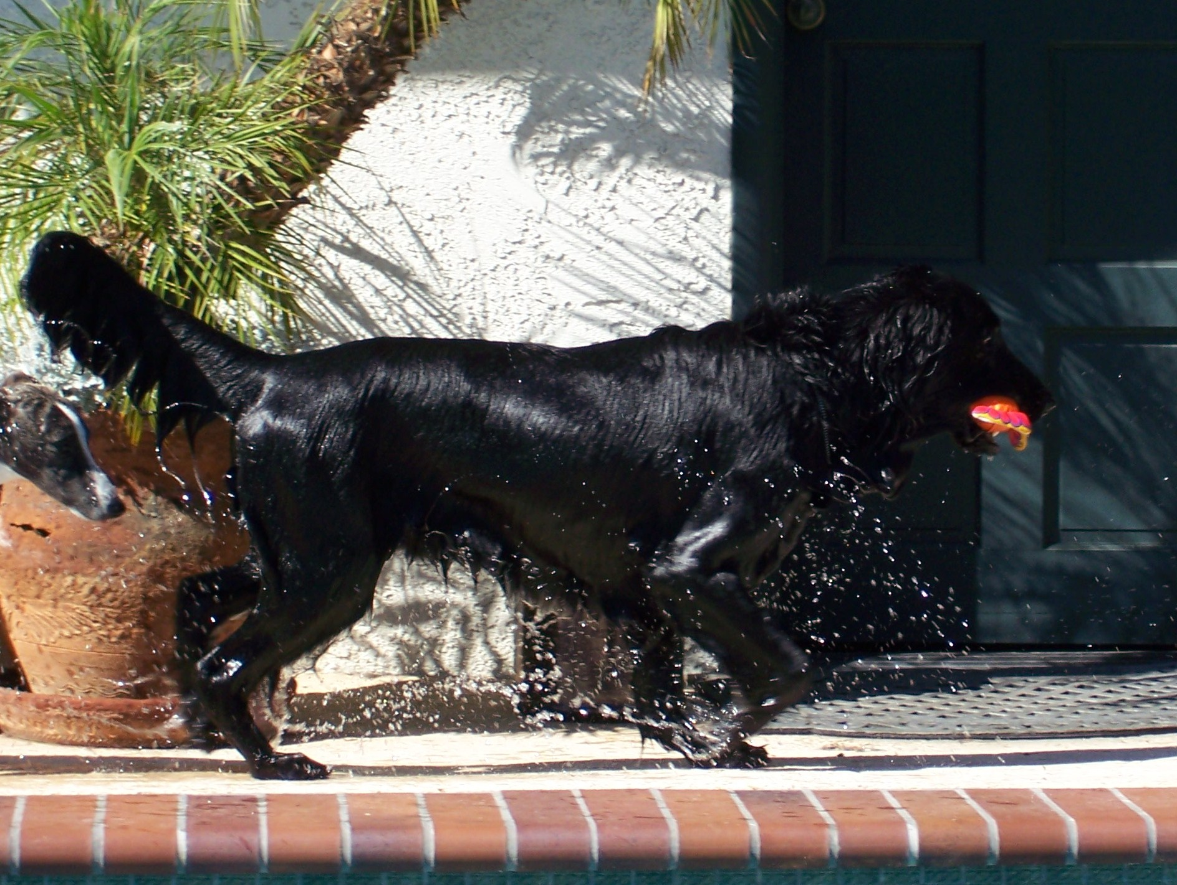
Jake is a well balanced black dog (carries liver) with excellent breed type and gorgeous movement. His beautiful headpiece is complimented by dark eyes and a pleasing, soft expression. His owners love his
biddability and temperament. He was imported from a Danish kennel that has produced several successful multi purpose dogs and he has an outstanding pedigree. We looked long and hard to find a dog to complement Patsy as nicely as Jake does!

Ch Flashback Crazy For Loving You CD CGC “Patsy”
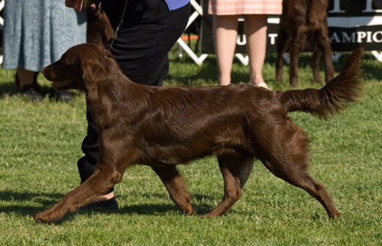
Patsy is a moderately sized, well balanced liver bitch with excellent angulation, level topline, nice prow, and a pleasing head. She comes from a very successful litter of 5 champions (2 others pointed), with multiple titles in field, agility, obedience and rally. Patsy inherited her mother's gorgeous movement; she and her dam ("Snicker") won the brace class as the 2007 Specialty. She has a wonderfully bright and cheery personality and LOVES to work!
Sire  CH HUNTLOVER’S JUMPING STAR OF BRISTOL SR10815601 | Sire  ALMANZA CHOCOLATE BRANDY WAFER | Sire  ALMANZA WILLIAM THE CONQUEROR
Sire  CH HUNTLOVER’S JUMPING STAR OF BRISTOL SR10815601 | Sire  ALMANZA CHOCOLATE BRANDY WAFER | Dam  ALMANZA MAD ABOUT CHOCOLATE
Sire  CH HUNTLOVER’S JUMPING STAR OF BRISTOL SR10815601 | Dam  TOFFEDREAM FOUR ROSES | Sire  COALPORT COUNTRY MAN
Sire  CH HUNTLOVER’S JUMPING STAR OF BRISTOL SR10815601 | Dam  TOFFEDREAM FOUR ROSES | Dam  O’FLANAGAN IMPOSANT
Dam  CH FLASHBACK CRAZY FOR LOVING YOU CD CGC SR27774106 | Sire  CASBLAIDD DON'T PAY THE FERRYMAN | Sire  WAVERTON TOBY ALE OF VARINGO
Dam  CH FLASHBACK CRAZY FOR LOVING YOU CD CGC SR27774106 | Sire  CASBLAIDD DON'T PAY THE FERRYMAN | Dam  CASBLAIDD DUTY FREE
Dam  CH FLASHBACK CRAZY FOR LOVING YOU CD CGC SR27774106 | Dam  CH CLAYMORE'S LIVE, LOVE, LAUGH NA NAJ NAP NJP | Sire  CH BLAZIN'S BACK O' THE MOON UD RN JH AX NAP NJP
Dam  CH FLASHBACK CRAZY FOR LOVING YOU CD CGC SR27774106 | Dam  CH CLAYMORE'S LIVE, LOVE, LAUGH NA NAJ NAP NJP | Dam  CH LYRIC'S KAY CD SH

